Project Report
PROJECT TITLE:-Employee Absenteeism
30 April 2019
Submitted by- romika malik

Contents
1. Introduction
1.1 Problem Statement . . . . . . . . . . . . . . . . . . . . . . . . . . . . . . . . . . . . . . . . . . 3
1.2 Data . . . . . . . . . . . . . . . . . . . . . . . . . . . . . . . . . . . . . . . . . . . . . . . . . . . . . . 3
1.3 Exploratory Data Analysis . . . . . . . . . . . . . . . . . . . . . . . . . . . . . . . . . . . . . 5
2. Methodology
2.1 Pre Processing . . . . . . . . . . . . . . . . . . . . . . . . . . . . . . . . . . . . . . . . . . . . . . 6
2.1.1 Missing Value Analysis . . . . . . . . . . . . . . . . . . . . . . . . . . . . . . . . . . . . . .7
2.1.2 Outlier Analysis . . . . . . . . . . . . . . . . . . . . . . . . . . . . . . . . . . . . . . . . . . . 8
2.1.3 Feature Selection . . . . . . . . . . . . . . . . . . . . . . . . . . . . . . . . . . . . . . . . . . 9
2.1.4 Feature Scaling . . . . . . . . . . . . . . . . . . . . . . . . . . . . . . . . . . . . . . . . . . . 10
2.1.5 Principal Component Analysis . . . . . . . . . . . . . . . . . . . . . . . . . . . . . . . 10
2.2 Modeling . . . . . . . . . . . . . . . . . . . . . . . . . . . . . . . . . . . . . . . . . . . . . . . . . . 11
2.2.1 Decision Tree. . . . . . . . . . . . . . . . . . . . . . . . . . . . . . . . . . . . . . . . . . . . . 11
2.2.2 Random Forest . . . . . . . . . . . . . . . . . . . . . . . . . . . . . . . . . . . . . . . . . . . .11
2.2.3 Linear Regression . . . . . . . . . . . . . . . . . . . . . . . . . . . . . . . . . . . . . . . . . 11
2.2.4 Gradient Boosting . . . . . . . . . . . . . . . . . . . . . . . . . . . . . . . . . . . . . . . . . 11
3. Conclusion
3.1 Model Evaluation . . . . . . . . . . . . . . . . . . . . . . . . . . . . . . . . . . . . . . . . . . . 13
3.2 Model Selection . . . . . . . . . . . . . . . . . . . . . . . . . . . . . . . . . . . . . . . . . . . . 13
3.3 Answers of asked questions . . . . . . . . . . . . . . . . . . . . . . . . . . . . . . . . . . 13
Appendix
Extra Figures . . . . . . . . . . . . . . . . . . . . . . . . . . . . . . . . . . . . . . . . . . . . . . . . . References

Chapter 1
Introduction

- Problem Statement
XYZ is a courier company. As we appreciate that human capital plays an important role in collection, transportation and delivery. The company is passing through genuine issue of Absenteeism. The company has shared it dataset and requested to have an answer on the following areas:
1. What changes company should bring to reduce the number of absenteeism?
2. How much losses every month can we project in 2011 if same trend of absenteeism continues?

- Data
Our task is to build a model that we precisely reduce the no. Of absenteeism due to which there occured a loss to the company.
We are given the below data:
There are 21 variables in our data in which 20 are independent variables and 1 (Absenteeism time in hours) is dependent variable. So as we have figured out that our target variable is continuous in nature, this problem is a regression problem exactly.
Variables Information:
The tabular format of the below given variables is:-
ID | Reason for absence | Month of absence | Day of the week | Seasons | Transportation expense | Distance from Residence to Work | Service time | Age | Work load Average/day | Hit target | Disciplinary failure | Education
11 | 26 | 7 | 3 | 1 | 289 | 36 | 13 | 33 | 2,39,554 | 97 | 0 | 1
36 | 0 | 7 | 3 | 1 | 118 | 13 | 18 | 50 | 2,39,554 | 97 | 1 | 1
3 | 23 | 7 | 4 | 1 | 179 | 51 | 18 | 38 | 2,39,554 | 97 | 0 | 1
7 | 7 | 7 | 5 | 1 | 279 | 5 | 14 | 39 | 2,39,554 | 97 | 0 | 1
The first 8 columns are:

The next 7 variables are:

Age | Work load Average/day | Hit target | Disciplinary failure | Education | Son | Social drinker
33 | 2,39,554 | 97 | 0 | 1 | 2 | 1
50 | 2,39,554 | 97 | 1 | 1 | 1 | 1
38 | 2,39,554 | 97 | 0 | 1 | 0 | 1
39 | 2,39,554 | 97 | 0 | 1 | 2 | 1

The next 6 variables are:-
Social smoker | Pet | Weight | Height | Body mass index | Absenteeism time in hours
0 | 1 | 90 | 172 | 30 | 4
0 | 0 | 98 | 178 | 31 | 0
0 | 0 | 89 | 170 | 31 | 2
1 | 0 | 68 | 168 | 24 | 4

The names and description of all columns are given below:-
1. Individual identification (ID)
2. Reason for absence (ICD) -
Absences attested by the International Code of Diseases (ICD) stratified into 21 categories (I to XXI) as follows:
I. Certain infectious and parasitic diseases
II. Neoplasms
III. Diseases of the blood and blood-forming organs and certain disorders involving the immune mechanism
IV. Endocrine, nutritional and metabolic diseases
V. Mental and behavioral disorders
VI. Diseases of the nervous system
VII. Diseases of the eye and adnexa
VIII. Diseases of the ear and mastoid process
IX. Diseases of the circulatory system
X. Diseases of the respiratory system
XI. Diseases of the digestive system
XII. Diseases of the skin and subcutaneous tissue
XIII. Diseases of the musculoskeletal system and connective tissue
XIV. Diseases of the genitourinary system
XV. Pregnancy, childbirth and the puerperium
XVI. Certain conditions originating in the perinatal period
XVII. Congenital malformations, deformations and chromosomal abnormalities
XVIII. Symptoms, signs and abnormal clinical and laboratory findings, not elsewhere classified
XIX. Injury, poisoning and certain other consequences of external causes
XX. External causes of morbidity and mortality
XXI. Factors influencing health status and contact with health services
And 7 categories without (CID) patient follow-up (22), medical consultation (23), blood donation (24), laboratory examination (25), unjustified absence (26), physiotherapy (27), dental consultation (28).
3. Month of absence
4. Day of the week (Monday (2), Tuesday (3), Wednesday (4), Thursday (5), Friday (6))
5. Seasons (summer (1), autumn (2), winter (3), spring (4))
6. Transportation expense
7. Distance from Residence to Work (kilometers)
8. Service time
9. Age
10. Work load Average/day
11. Hit target
12. Disciplinary failure (yes=1; no=0)
13. Education (high school (1), graduate (2), postgraduate (3), master and doctor (4))
14. Son (number of children)
15. Social drinker (yes=1; no=0)
16. Social smoker (yes=1; no=0)
17. Pet (number of pet)
18. Weight
19. Height
20. Body mass index
21. Absenteeism time in hours (target)

Chapter 2
Methodology
At first, we need to feed the data to the model. But before we feed the data to the model we need to make sure clean the data and convert it to a suitable format. It is the most crucial part of any of the data science project and ideally we are supposed to spend maximum time on it to get clean data.
2.1 Pre Processing
Any predictive modeling requires that we look at the data before we start modeling. However, in data mining terms looking at data refers to so much more than just looking. Looking at data refers to exploring the data, cleaning the data as well as visualizing the data through graphs and plots. This is often called as Exploratory Data Analysis. To start this process we will first try and look at all the probability distributions of the variables. Most analysis like regression, require the data to be normally distributed. We can visualize that in a glance by looking at the probability distributions or probability density functions of the variable. In order to know more findings, we will fetch the simple mean, median values of the data as well.
2.2 Exploratory Data Analysis
Exploratory Data Analysis (EDA) is the first step in your data analysis process. Here, you make sense of the data you have and then figure out what questions you want to ask and how to frame them, as well as how best to manipulate your available data sources to get the answers you need.Exploratory Data Analysis (EDA) is an approach to analyzing data sets to summarize their main characteristics. In the given data set there are 21 variables and data types of all variables are either float64 or int64. There are 740 observations and 21 columns in our data set. Missing values are also present in our datas evident by looking at the data or by using isnull() function .
List of columns and their number of unique values -
ID 36
Reason for absence 28
Month of absence 13
Day of the week 5
Seasons 4
Transportation expense 24
Distance from Residence to Work 25
Service time 18
Age 22
Work load Average/day 38
Hit target 13
Disciplinary failure 2
Education 4
Son 5
Social drinker 2
Social smoker 2
Pet 6
Weight 26
Height 14
Body mass index 17
Absenteeism time in hours 19

From EDA we have concluded that there are 10 continuous variable and 11 categorical variable in nature.

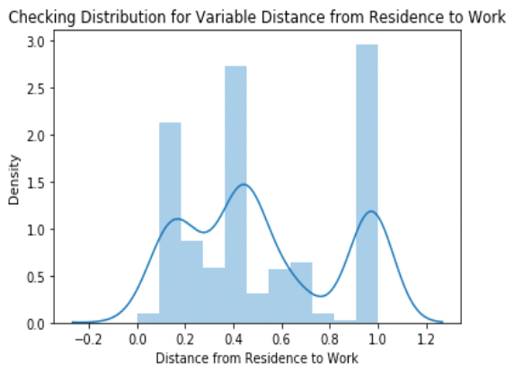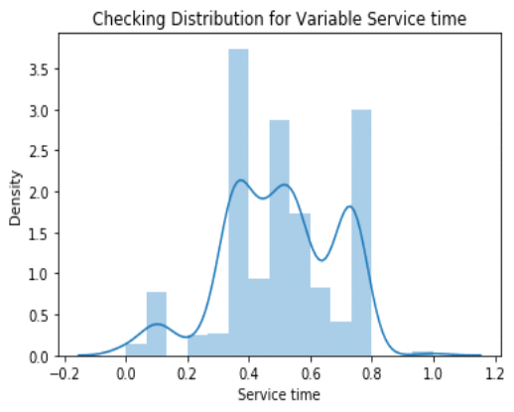
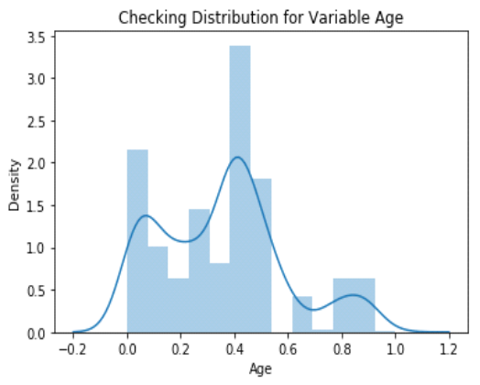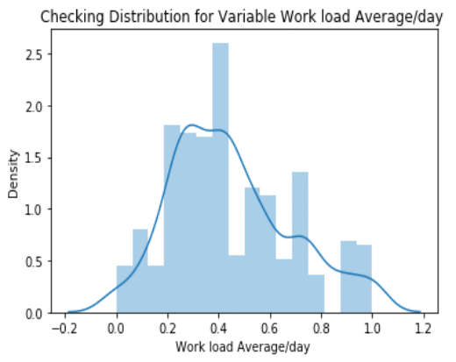
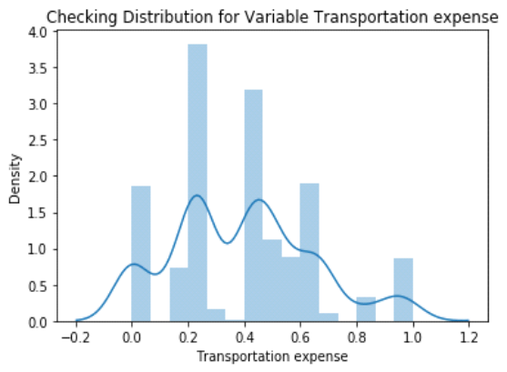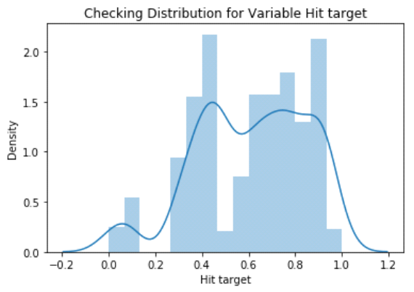

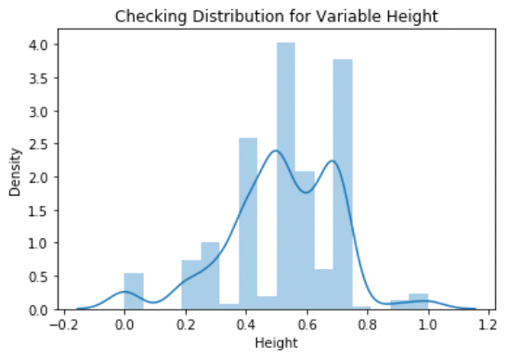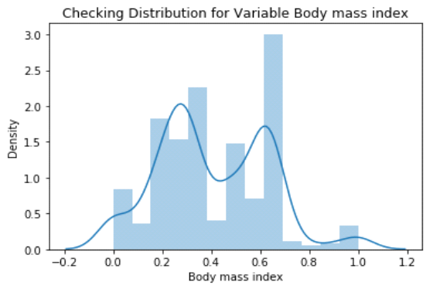

2.2.1 Missing Value Analysis
Missing value analysis helps address several concerns caused by the incompletion of data. If cases with these missing values are systematically different from cases without missing values, the results can be misleading often. Also, missing data might reduce the precision of the calculated statistics because there is much less information than originally planned. Another concern is that the assumptions behind many of the statistical procedures are based on the complete cases, and missing values can complicate the theory required.In statistics, missing data, or missing values, occurs when no data value is stored for the variable in an observation. Missing data are a common occurrence and can have a significant effect on the conclusions that can be drawn from the data. If a columns has more than 30% of data as missing value either we ignore the entire column or we ignore those observations. In the given data the maximum percentage of missing value is 4.189% for body mass index column. So we will compute missing value for all the columns.
In this project we have used some of the the missing value imputation methods like replacing missing value with mean/medians but finally we chose KNN imputation to impute missing value because it gave much more accurate and precised value.
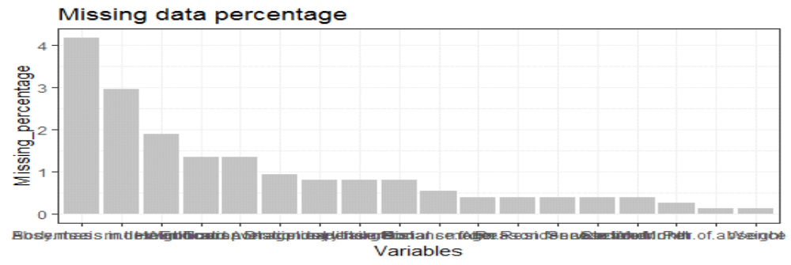I have stored the missing data percentage into another excel sheet as well.
2.1.2 Outlier Analysis
We can clearly observe from these probability distributions that most of the variables are skewed. The skew in these distributions can be most likely be explained by the presence of outliers and extremity of the values in the data. One of the crucial steps of pre-processing apart from checking for normality is the presence of outliers. In this case we use a classic approach of removing outliers. We visualize the outliers using boxplots.
In figure we have plotted the boxplots of the 11 predictor variables with respect to Absenteeism time in hour. A lot of useful inferences can be made from these plots. Firstly as you can see, we have a lot of outliers and extreme values in each of the data set.

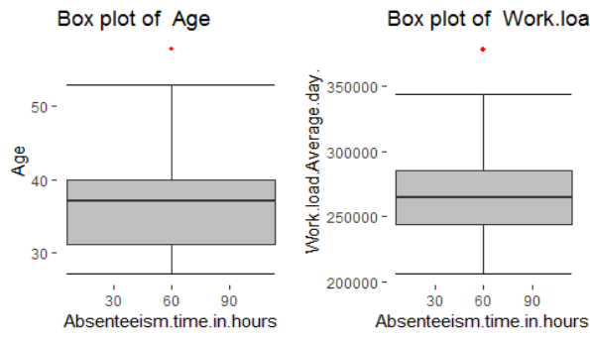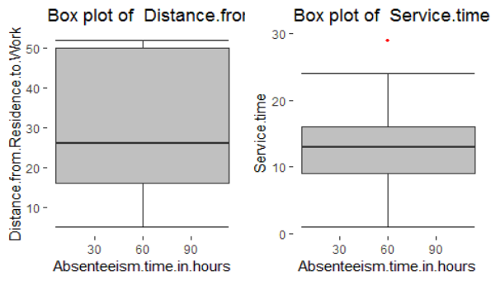

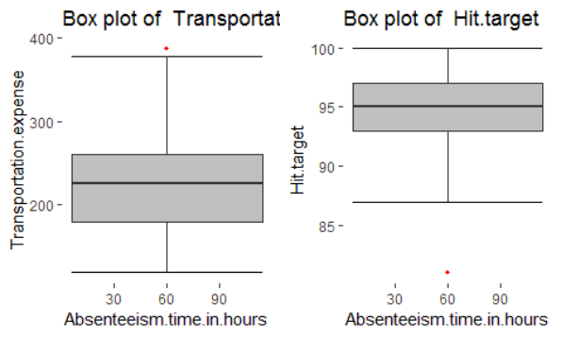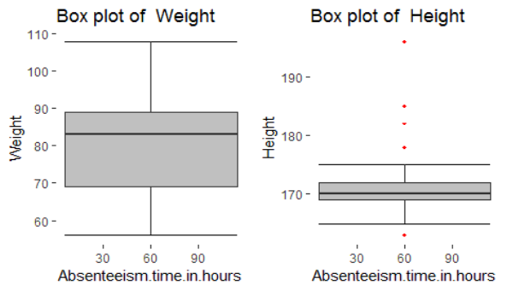

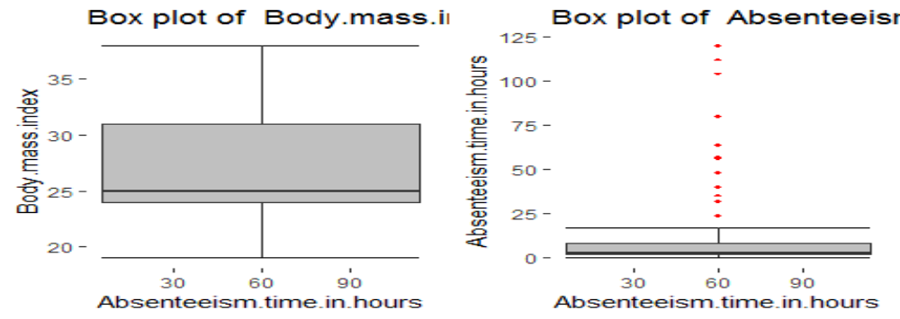
From the boxplot almost all the variables except “Distance from residence to work”, “Weight” and “Body mass index” consists of some of the outliers. We have converted the outliers (data beyond minimum and maximum values) as NA i.e. missing values and filled them by KNN imputed value.
2.1.3 Feature Selection
Feature Selection is the process where you automatically or manually select those features which contribute most to your prediction variable or output in which you are interested in.Before performing any type of modeling we need to assess the importance of each predictor variable in our analysis. There is a possibility that many variables in our analysis are not important at all to the problem of class prediction. Selecting subsequent subset of relevant columns for the model construction is known as the Feature Selection. We cannot use all the features because some features may be carrying the same information or irrelevant information which can increase overhead. To reduce overhead we adopt feature selection technique to extract meaningful features out of data. This in turn helps us to avoid the problem of multi-collinearity. In this project I have selected the below ones:-
Correlation Analysis for numerical variable and ANOVA (Analysis of variance) for categorical variable.

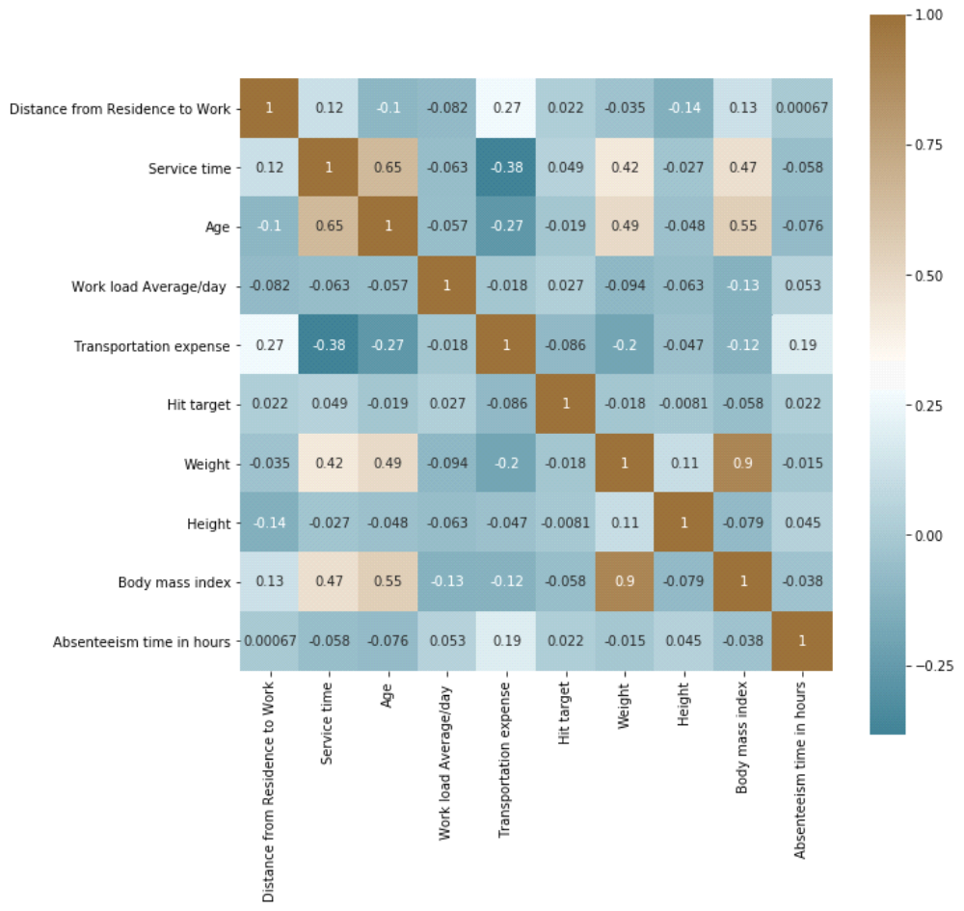

From correlation analysis we have found that Weight and Body mass index has high correlation (>0.7), so we have excluded the Weight column.
2.2.4 Feature Scaling
Feature scaling is a method used to standardize the range of independent variables or features of data. In data processing, it is also known as data normalization and is generally performed during the data preprocessing step. Since the range of values of raw data varies widely, in some machine learning algorithms, objective functions will not work properly without normalization. For example, the majority of classifiers calculate the distance between two points by the Euclidean distance. If one of the features has a broad range of values, the distance will be governed by this particular feature. Therefore, the range of all features should be normalized so that each feature contributes approximately proportionately to the final distance. Since our data is not uniformly distributed we will use Normalization as Feature Scaling Method.

2.2.5 Principal Component Analysis(PCA)
Principal component analysis (PCA) is a statistical procedure that uses an orthogonal transformation to convert a set of observations of possibly correlated variables (entities each of which takes on various numerical values) into a set of values of linearly uncorrelated variables called principal components. If there are n {\displaystyle n} observations with p {\displaystyle p} variables, then the number of distinct principal components is min ( n − 1 , p ) {\displaystyle \min(n-1,p)} .Principal component analysis is a method of extracting important variables (in form of components) from a large set of variables available in a data set. It extracts low dimensional set of features from a high dimensional data set with a motive to capture as much information as possible. With fewer variables, visualization also becomes much more meaningful. PCA is more useful when dealing with 3 or higher dimensional data. After creating dummy variable of categorical variables the shape of our data became 107 columns and 714 observations, this high number of columns leads to bad accuracy.

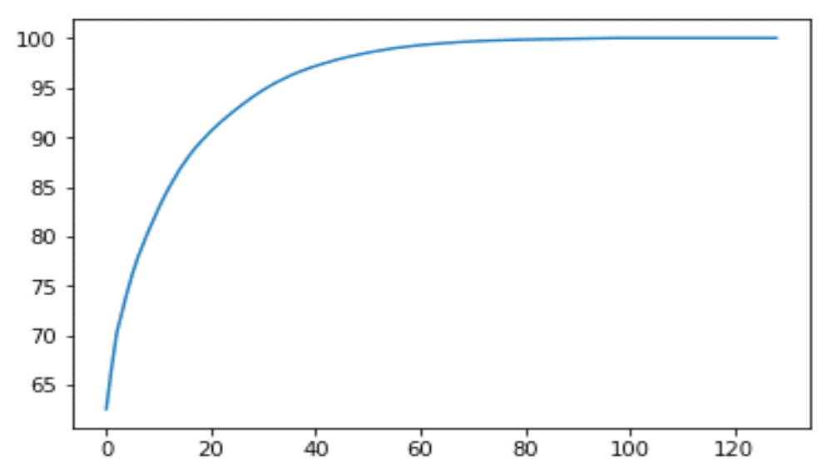

We have applied PCA algorithm on our data and from the above graph we have concluded that 45 variables out of 107 explains more than 95% of data. So we have selected only those 45 variables to feed our models.

2.2 Modeling of the Data
After a thorough preprocessing of the data, now we will be using some regression models on our processed data to predict the target variable. Following are the models which we have built upon for prediction –

2.2.1 Decision Tree
Decision tree is the most powerful and popular tool for classification and prediction. A Decision tree is a flowchart like tree structure, where each internal node denotes a test on an attribute, each branch represents an outcome of the test, and each leaf node (terminal node) holds a class label.A decision tree basically is a decision support tool that uses a tree-like graph or model of decisions and their possible consequences, including chance event outcomes, resource costs, and utility. Each branch connects nodes with “and” and multiple branches are connected by “or”. It can be used for classification and regression. It is a supervised machine learning algorithm. Accept continuous and categorical variables as independent variables. Extremely easy to understand by the business users. Split of decision tree is seen in the below tree. The RMSE value and R^2 value for our project in R and Python are –

Decision Tree | R | PYTHON
RMSE Train | 0.410 | 0.573
RMSE Test | 0.363 | 0.568
R^2 Test | 0.98 | 0.96

2.2.2 Random Forest
Random Forest is a flexible, easy to use machine learning algorithm that produces, even without hyper-parameter tuning, a great result most of the time. It is also one of the most used algorithms, because it’s simplicity and the fact that it can be used for both classification and regression tasks.Random Forest is an ensemble technique that consists of many decision trees. The idea behind Random Forest is to build n number of trees to have more accuracy in dataset. It is called random forest as we are building n no. of trees randomly. In other words, to build the decision trees it selects randomly n no of variables and n no of observations to build each decision tree. It means to build each decision tree on random forest we are not going to use the same data. The RMSE value and R^2 value for our project in R and Python are –

Random Forest | R | PYTHON
RMSE Train | 0.369 | 0.033
RMSE Test | 0.614 | 0.029
R^2 Test | 0.96 | 0.99

2.2.3 Liner Regression
Linear regression is a linear model, e.g. a model that assumes a linear relationship between the input variables (x) and the single output variable (y). More specifically, that y can be calculated from a linear combination of the input variables (x).When there is a single input variable (x), the method is referred to as simple linear regression. When there are multiple input variables, literature from statistics often refers to the method as multiple linear regression.Linear Regression is one of the statistical methods of prediction. It is applicable only on continuous data. To build any model we have some assumptions to put on data and model. Here are the assumptions to the linear regression model.

Linear Regression | R | PYTHON
RMSE Train | 0.001 | 4.34e-15
RMSE Test | 0.001 | 4.14e-15
R^2 Test | 0.99 | 1

2.2.4 Gradient boosting
Gradient boosting is a machine learning technique for regression and classification problems, which produces a prediction model in the form of an ensemble of weak prediction models, typically the decision trees. It builds up the model in a stage-wise fashion like other boosting methods do, and it generalizes them by allowing optimization of an arbitrary differentiable loss function.When you print a gbm model, it will remind you how many trees or iterations were used in its execution. Using its internal calculations such as Variable Importance, it will also point whether any of the predictor variables had zero influence in the model.
Gradient boosting | R | PYTHON
RMSE Train | 2.276 | 0.001
RMSE Test | 1.818 | 0.001
R^2 | 0.91 | 0.99

Chapter 3
Conclusion
In this chapter I am going to evaluate our models, select the best model for the dataset for prediction of appropriate values. Also, I would like to share the answers of the asked questions based upon my analysis and applied methods.

3.1 Model Evaluation
In the previous chapter, I have seen the Root Mean Square Error (RMSE) and R-Squared Value of different models. Root Mean Square Error (RMSE) is the standard deviation of the residuals (prediction errors). Residuals are a measure of how far from the regression line data points are, RMSE is a measure of how spread out these residuals are. In other words, it tells you how concentrated the data is around the line of best fit. Whereas R-squared is a relative measure of fit, RMSE is an absolute measure of fit. As the square root of a variance, RMSE can be interpreted as the standard deviation of the unexplained variance, and has the useful property of being in the same units as the response variable. Lower values of RMSE and higher value of R-Squared Value indicate better fit.

3.2 Model Selection
From the observation of all RMSE Value and R-Squared Value , I have concluded that Linear Regression Model has minimum value of RMSE and it’s R-Squared Value is also maximum (i.e. 1).
The RMSE value of Testing data and Training does not differs a lot this implies that it is not the case of overfitting.

3.2 Answers of asked questions
The Changes which company should bring to reduce the number of absenteeism –
- It has been observed that employee with low education have maximum absentee time.

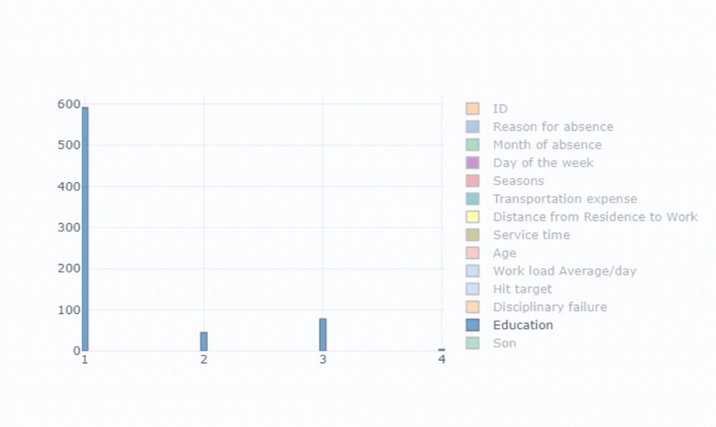
- Also, some of the employees with ID 3, 28, 34 are often absent from work, company should take action against them.

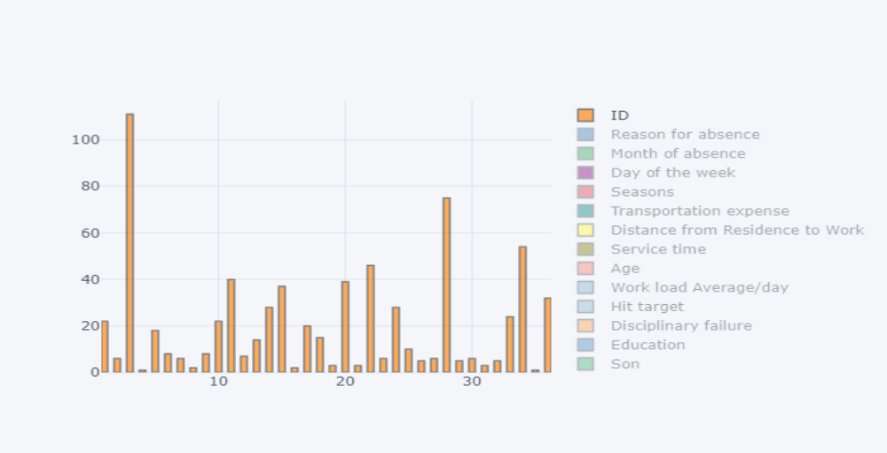

- Employees who are social smoker have more absenteeism hour than who are not social smoker.

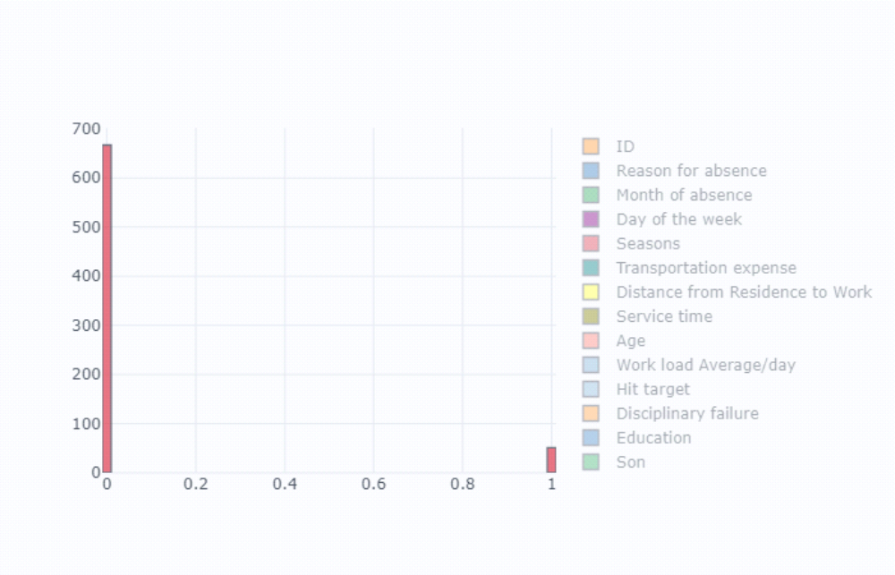

- One of the most obvious reason for absence are medical consultations and dental consultations, due to which employees are more prone to take leaves and should be paid heed to.

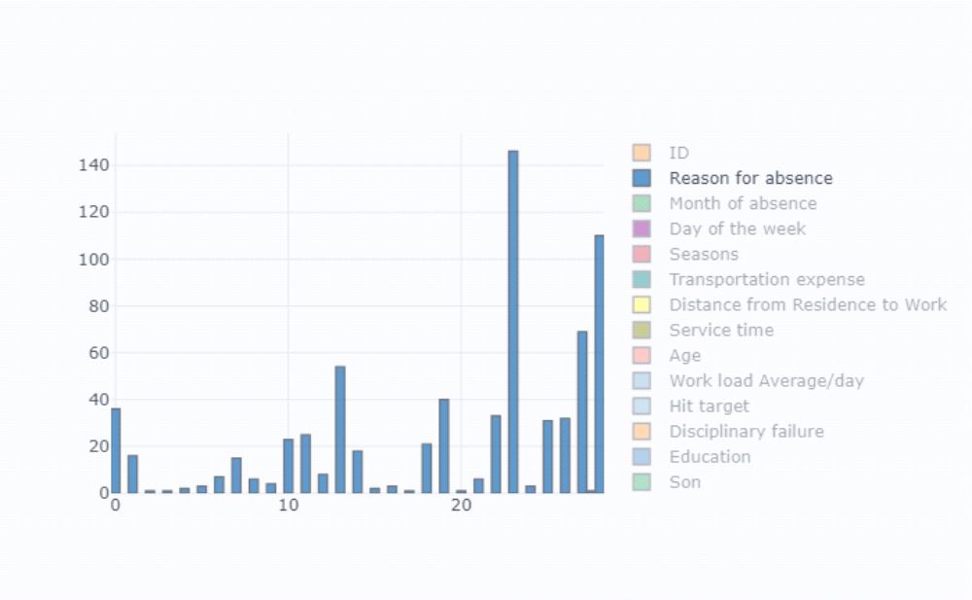

- Employees who has Distance from Residence to Work are more prone to get abesnt from work oftenly..

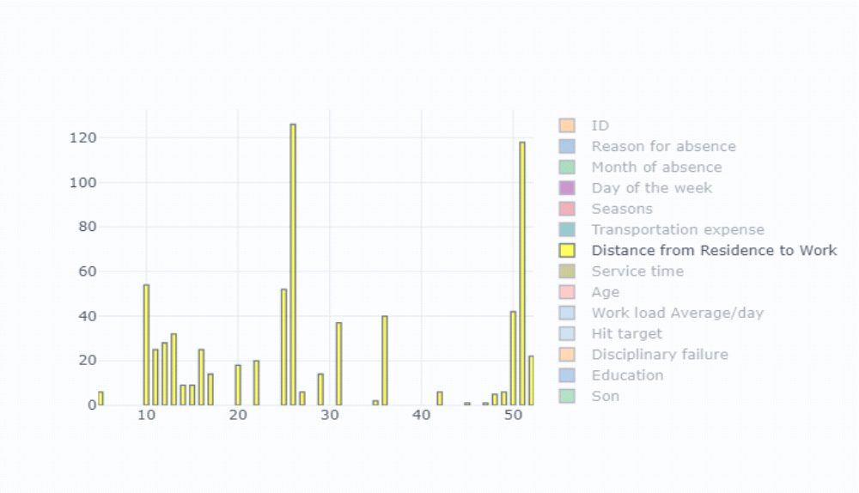
Appendix
Extra Figures
Relationship of our target variable (Absentee time in hour) with other variables.
- With “Age”
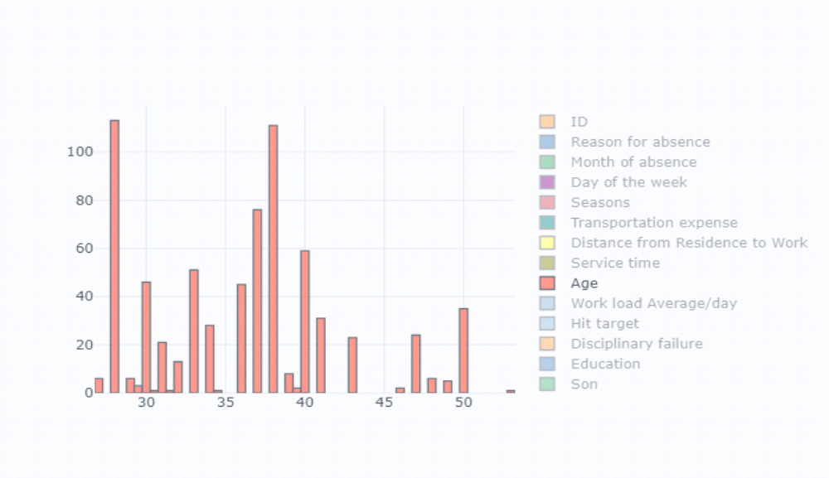

- With “Body mass index”
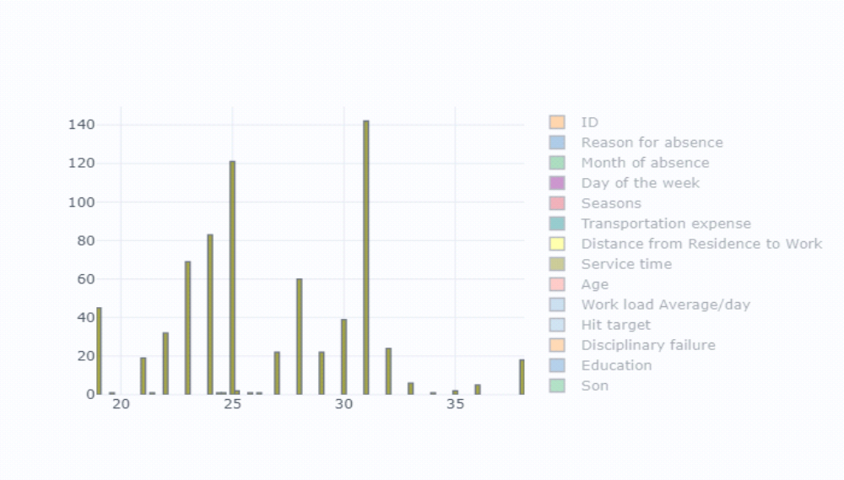
- With “Day of week”
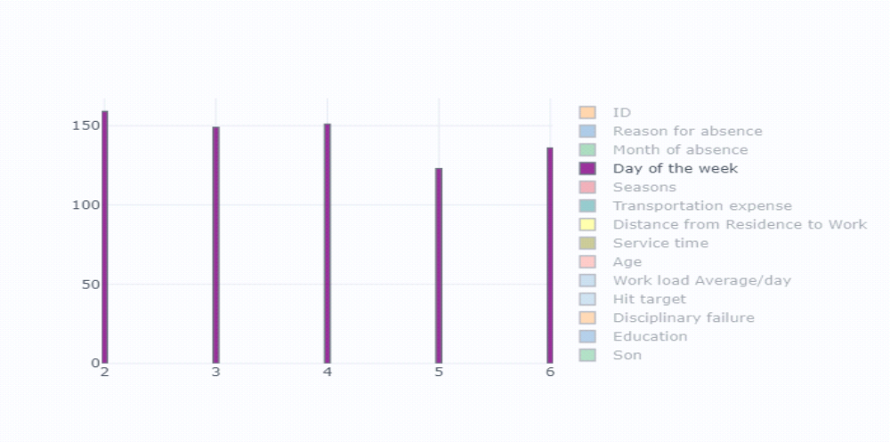

- With “Disciplinary failure”
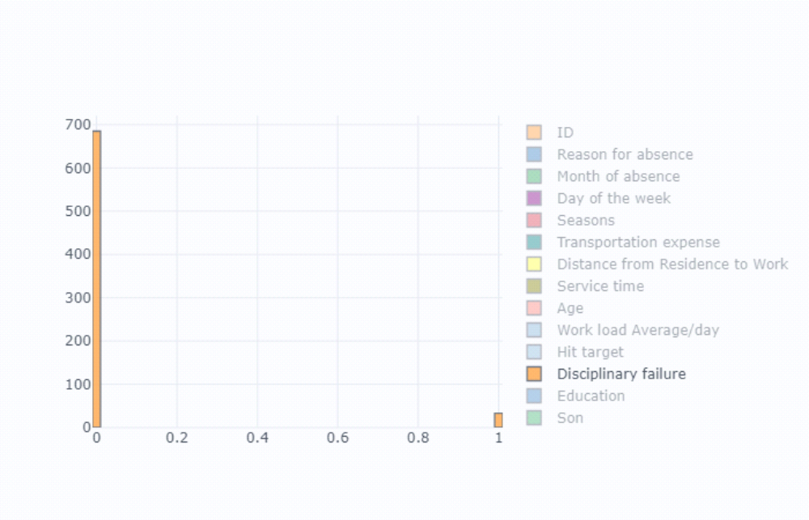

- With “Height”
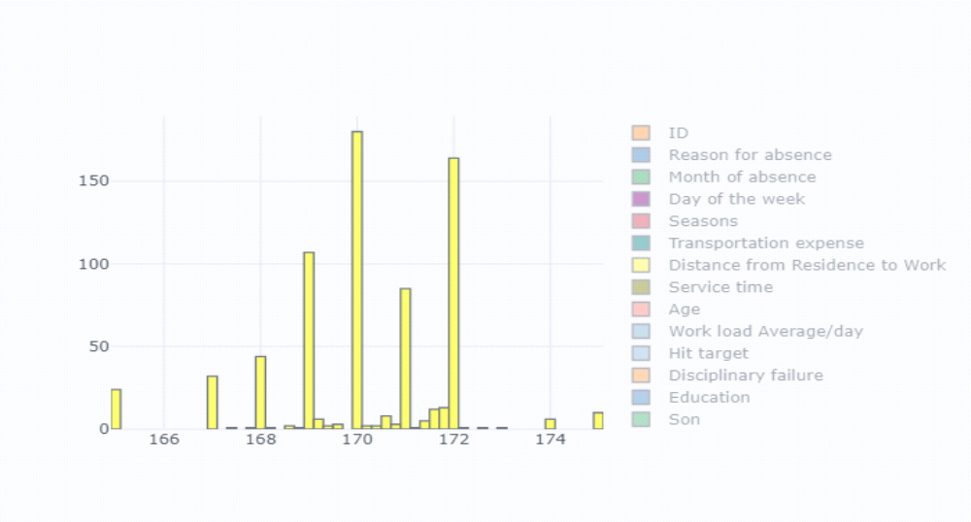

- With “Hit target”
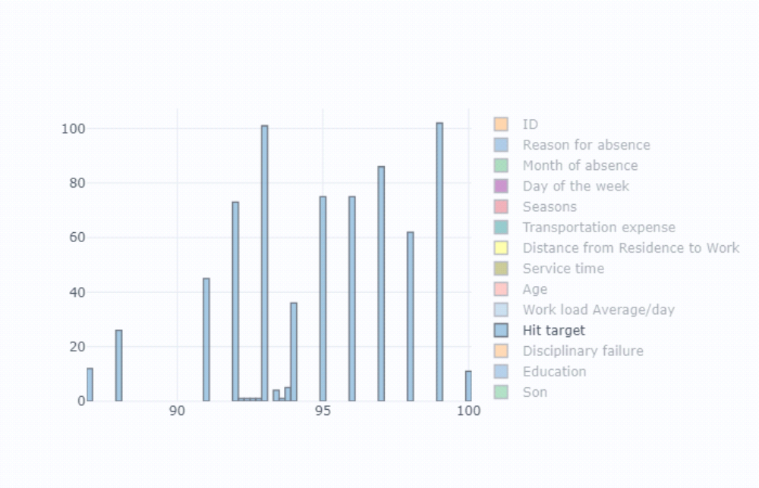

- With “Month of absent”
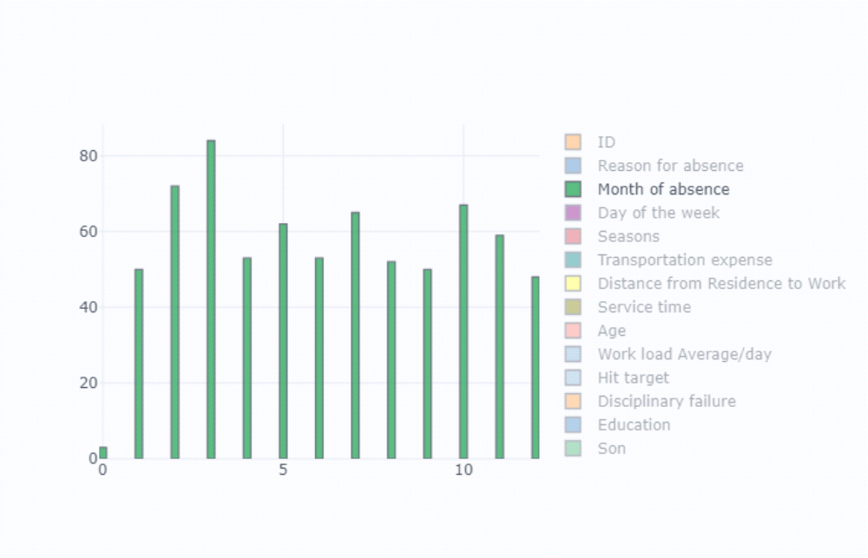

- With “Pet”
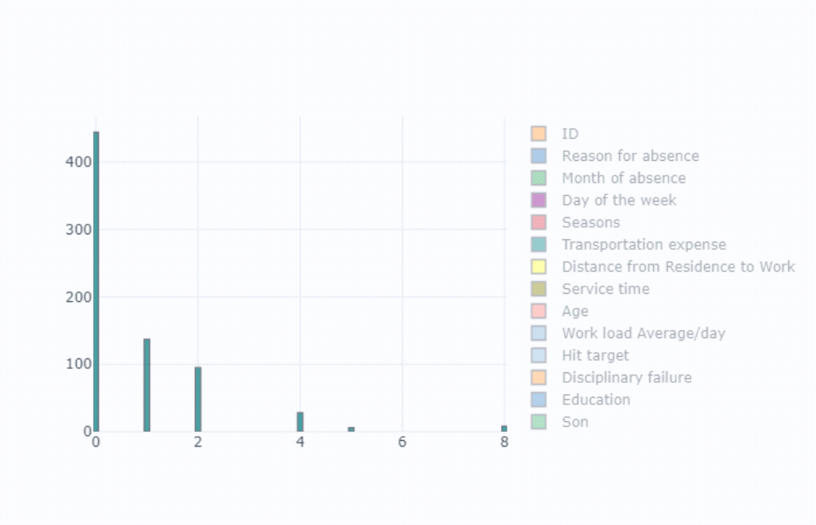
- With “Seasons”
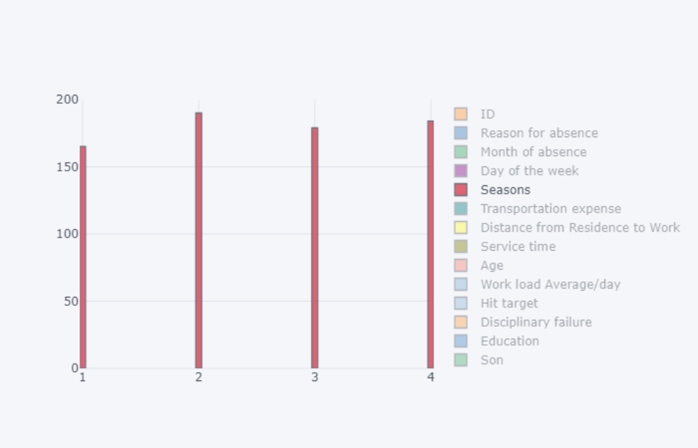

- With “Service time”
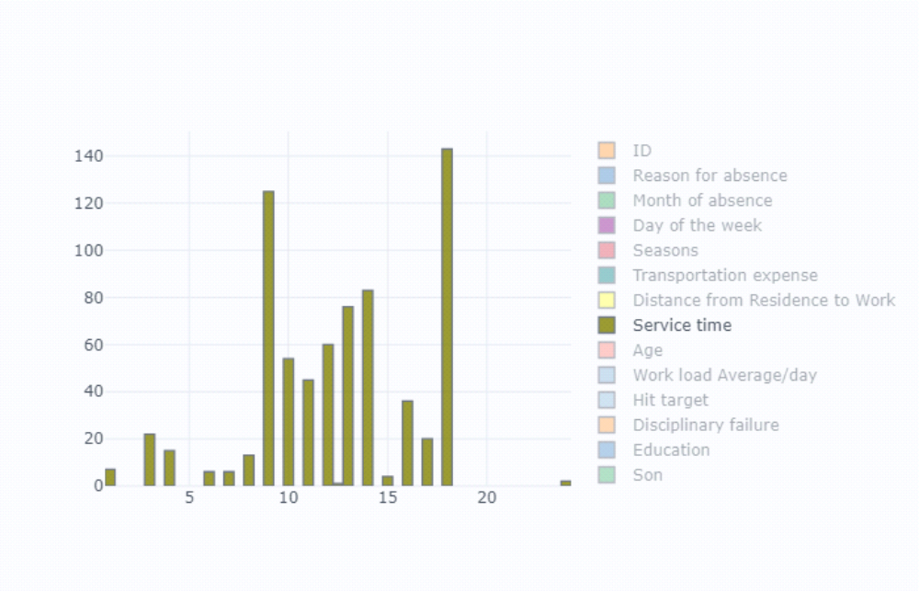
- With “Social drinker”
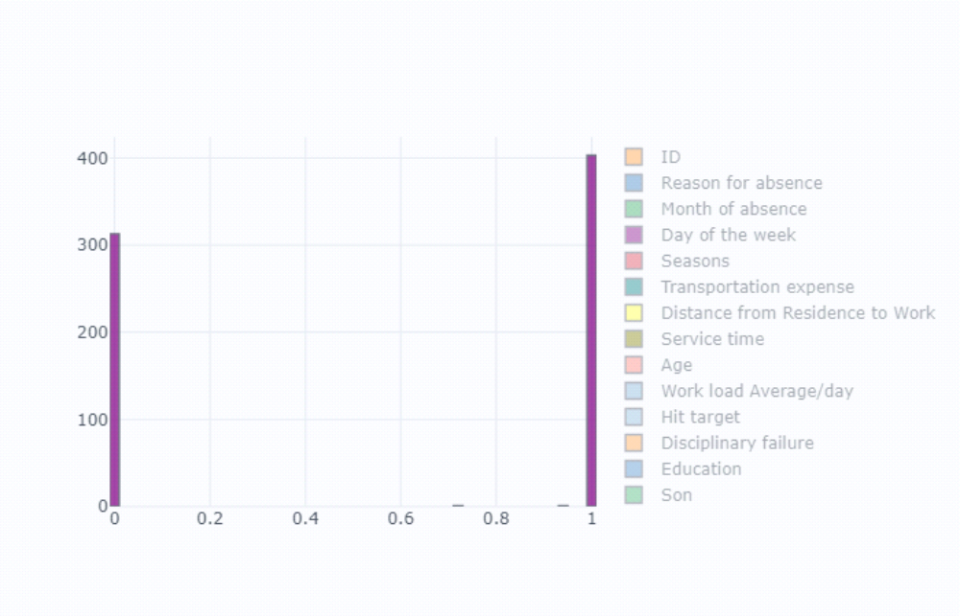

- With “Son”
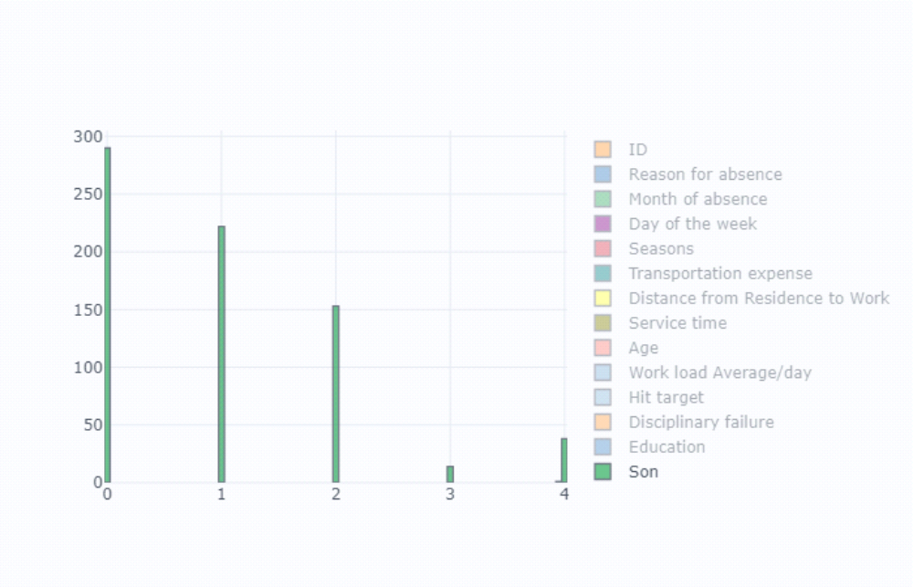
- With “Transportation Expense”
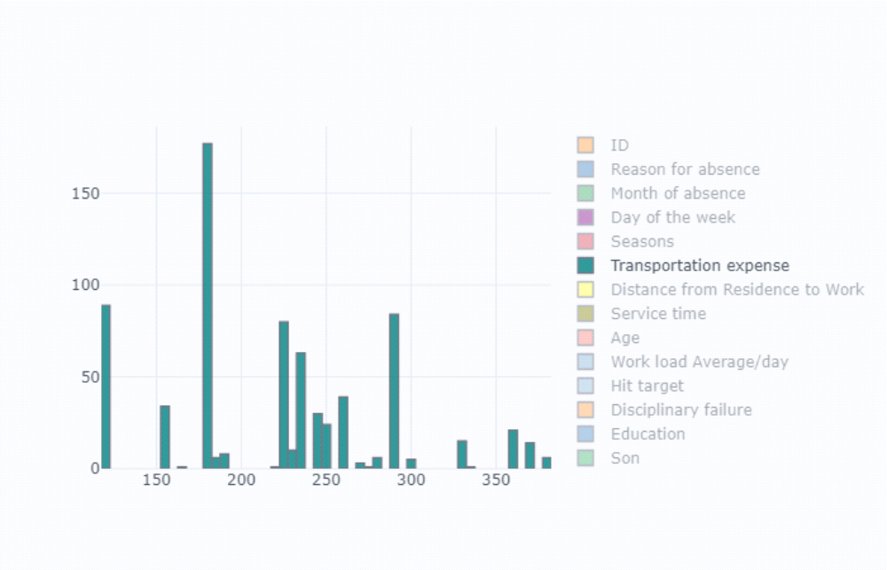

- With “Work load/day”
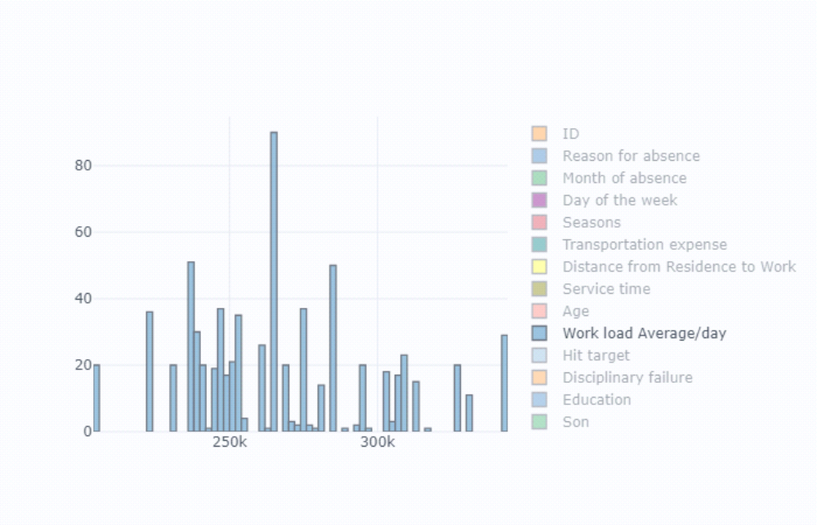

References

- https://edwisor.com/career-data-scientist
- http://en.wikipedia.org
- https://towardsdatascience.com
- www.kaggle.com
- https://www.udemy.com/python-for-data-science-and-machine-learning-bootcamp/

